Hasil data Regresi Panel Revita Dwi Handayani

Statistik Deskriptif
 | WTP | ROA | CR | RETURN_SAHAM
Mean | 0.758721 | 0.020471 | 2.384589 | 0.003453
Maximum | 1.000000 | 0.204354 | 11.39784 | 0.274000
Minimum | 0.000000 | -0.218219 | 0.210118 | -0.066667
Std. Dev. | 0.427984 | 0.082175 | 2.449193 | 0.034789
Observations | 1720 | 1720 | 1720 | 1720

Uji kelayakan model panel

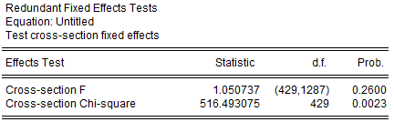

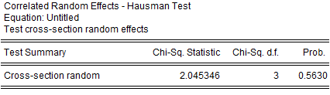
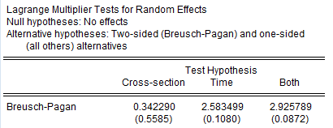
Uji Multikolinearitas

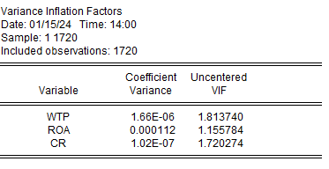

Uji Heterokedastisitas

Hasil Regresi
